Introduction
The author has a complete theory of weather from equator to pole and sea level to ionosphere. The perspective of this work is drastically different from prevailing meteorological approaches to weather theory. The primary difference is a physics-based dynamics approach to research as opposed to empirical kinematics-based weather solutions.
Kinematics provides reduced effort rule-of-thumb solutions, which work within preset boundaries after following an agreed set of requisite assumptions. Dynamics provide force-based dynamic solutions without qualifiers.
An example of incomplete and/or misapplication of scientific principles is the Coriolis Effect. The commonly stated concept is that any tangential (horizontal) movement of the atmosphere results in a lateral (perpendicular) displacement. Nothing could be further from the truth.
Many requisites limit the Coriolis Effect. One is its application solely to meridional atmospheric movement. The Coriolis Effect is only effective if the atmosphere follows the Earth's contour. Because they are not well understood, contemporary literature does not mention these essential limitations. These misunderstandings are due to ineffective application of physical effects to meteorology.

Horizontal weather
Cell theory, the current synoptic weather theory, relies on horizontal axis rolling air transfer between the latitudes. Air rises near the equator and descends after a poleward trajectory of ≈ 30 degrees. No force to initiate this movement outside the vertical force of differential air density acted on by gravity. This arrangement explains vertical movement but not horizontal movement.
This leads to a new framework, which I call Hunt Circulation. In Hunt Circulation theory, centrifugal force from the spinning earth provides an alternative explanation for meridional movement. Dense cold, dry polar air will displace buoyant tropical air providing ground or ocean level meridional air movement. For example, cold, dry dense southbound air travels over North America to the Caribbean displacing warm, humid buoyant air to the northeast toward northern Europe.
The prime difference between cell theory and the proposed theory is that with the exception of extreme weather events, most air remains at ground level at all latitudes. The atmosphere does not pass over on itself northward travels and under itself on southward travels as depicted in cell theory. Instead, it passes side by side as described in the previous paragraph. Said another way, Cell theory described an atmosphere moving continental distances while taking an oblique path around a horizontal axis that runs parallel to latitude lines. The Hunt circulation theory describes air moving continental distances around the globe in a path determined by earth's topology and driven by Tangential Weather Force.
The Hunt Circulation model is not a simple geometric change to Cell theory, but a mechanism to explain and quantify large-scale atmospheric phenomena through physical force interactions.

Background
The Earth would be a frigid lifeless hunk of rock without the sun's energy. But the sun alone does not make life possible. The atmosphere is truly the earth's fluid of life. A true understanding of the basic science of the atmosphere should be our highest priority. Sadly, theories from a century ago dominate contemporary meteorological science.
Most solar energy heats a narrow horizontal band within a few hundred miles of the solar equator. Virtually no energy arrives near the Polar Regions. Without horizontal weather forces the earth would be an arid desert near the equator and a frozen sheet of ice at the middle latitudes, including Europe and most of North America.
The atmosphere's meridional (north - south) movement results in thermal equalization of our world. Differential density caused by heat and humidity gained in equatorial regions produces transport force moving buoyant air to Polar Regions. Air temperature alone is not capable of this miracle of increased habitability. Water is an essential component. Water in the form of humidity is like a huge battery storing energy in the form of humidity for transport from the equatorial regions toward the Arctic regions. It can do this because its state transitions (gas- liquid- solid) require large amounts of energy. It is fortunate that these state transitions are within the range of temperatures conducive to life.
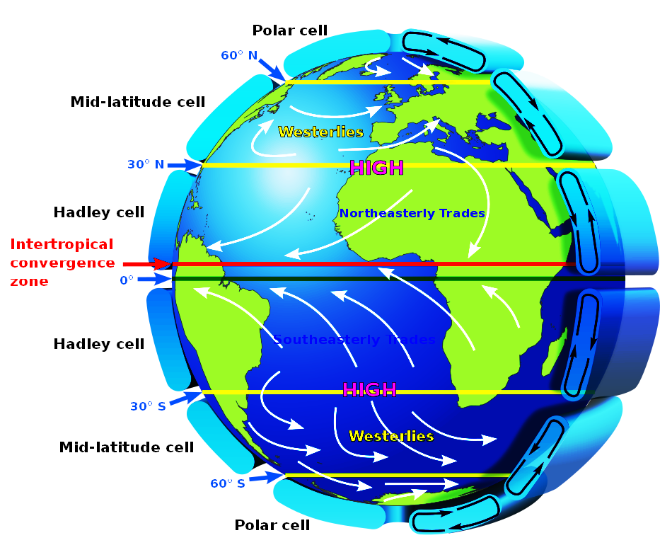
Currently accepted models including Hadley, Ferrel and Polar Cell theory requires rising vertical airflow from the ocean's surface in some regions, high altitude meridional movement, vertical airflow to return to the earth's surface before returning to the point of origin. The Hadley Cell's vertical airflow is from ocean/ground level to the upper troposphere, where it moves toward the poles for 30 degrees. At 30 degrees latitude it falls back to ocean/ground level before returning to equatorial regions at low altitude. This theory debunks itself because of the lack of water transport. All water would condense as rain or ice before rising two miles above the ocean. There is the lack of motivation, since there is no force to motivate that air movement toward the poles.
Figure 1
Movement toward the poles requires reducing axial displacement. Reducing axial displacement requires an accelerating force and there is no differential (directional) force available.

Continental airflow
Hunt circulation is an alternative model. Cold-dry-heavy northern latitude air flows toward the equator due to earth's centrifugal force. Heavier (denser) northern air displaces warm-humid-buoyant tropical air northward. The dense northern air moves toward equatorial regions and buoyant southern air moves to Polar Regions at ground and ocean level.
The simplest example of this process is the North American continent. Air over Polar, Alaskan and Canadian land cools and dries air more quickly than air over the Pacific Ocean or Atlantic Ocean. Extremely cold and dry air becomes quite dense. Centrifugal force accelerates the cold-dry heavy (dense) air mass down the plains. West coast (Rocky Mountains) and east coast (Appalachian Mountains) mountain ranges are effectively corridors guiding the flow southeast until they reach Caribbean areas such as the American Gulf. Buoyant air from the Caribbean is displaced eastward and northward traveling up the U.S. eastern coast to the North Atlantic and Northern Europe.
The northwest to southeast North American corridor bias that gives global air flow its net eastern component. Air leaving the Caribbean toward the northeast creates flow from the western North Atlantic to Western Europe. The more northern component of Caribbean northeast flow continues over Scandinavia into Northern Asia drying as it goes to provide frigid northern air for Asian Russia. Various east-west oriented mountain chains combine to ferry air horizontally west to east through northern Asia. European air from the Caribbean via Northwest Europe funnels into Southeast Asia by various east-west oriented European and South Asian mountain chains, especially those on the northern periphery of the Mediterranean Sea.
Hunt circulation has all the requisite components to maintain both south-north meridional motion and periodic eastward motion. The atmosphere's north and south zigzag motion is due to the force, guidance and continuity established over North America. It is common knowledge that the storms of northwest Europe comes mainly from the Caribbean Sea.
A Chinese weather balloon demonstrated airflow from Southeast Asia to Alaska, Canada and down the North American plains. Among other things, it proved that high altitude air doesn't switch directions between a Hadley Cell and a Ferrell Cell (mid-latitude cell) or get stuck between them.
Asian airflow is similar but significantly different. East-west mountain chains such as the Himalayan Mountains affect south flowing air reducing the cold air inflow to southeast China. Despite these differences, cold-dense continental air from North Asia accelerates into Southeast Asia displacing buoyant Southeast Asian air north and east to arrive in the Arctic, Alaska, Canada and Northwest America as described in the previous paragraph.
Other continents have significant east-west mountain ranges that affect their weather. The Pyrenees between Spain and France and the ring of mountains north of the Mediterranean Sea reduce northern airflow into North Africa reducing European moisture that would otherwise be available to North Africa and contributing to the Saharan Desert. The Himalayan Mountains reduce cold air intrusion from Siberia into India keeping the country warm.
The Hunt Circulation model explains airflow results such as the deserts on the west coast of North America, Southwest Africa and South America because they receive dried Arctic air. East-west mountain chains north and south of the great Asian deserts provide the most striking example of areas shielded from the positive effects of moist north-south flowing airflow.
The Hunt Circulation model also accounts for diurnal moisture flows from the eastern shores of most continents as well as the desert conditions created by Australia's Great Dividing Range a mountain range extending along Australia's east coast blocking diurnal water migration from the east coast.

Ocean Airflow
Primary airflow in the North Atlantic is a clockwise triangle. Leg 1 from the Caribbean to the North Atlantic is due to buoyant tropical air displaced by southeast flow over North America's Great Plains. Heat and moisture is lost in Polar Regions increasing air density. Dense Arctic air accelerates down the west coast of Europe to the southeast Atlantic off the coast of Africa. Southeast Atlantic Ocean air moves from east to west to replace buoyant Caribbean air headed to Western Europe.
Primary airflow in the North Pacific is a clockwise triangle. Leg 1 from Southeast Asia to the North Pacific is due to buoyant tropical air displaced by southeast flow from North Asia and eastern flow from the Indian Ocean. Heat and moisture is lost in Polar regions increases air density. Dense Arctic air accelerates down the west coast of North America to the southeast Pacific off the coast of North America and Mexico. Southeast Pacific Ocean air moves from east to west to replace buoyant southeastern air headed to Alaska, Canada and the northwest United States.
Similar airflows exist in the southern Atlantic and Pacific.

Ocean water flow
Ocean surface flow is primarily the result of fluid shear between the atmosphere and the ocean. The phenomenon of 'pile up' is where water accelerated by the atmosphere/ocean interface provides adequate momentum to raise water levels by feet at shorelines.
Clockwise airflow of oceanic surface water over Northern Hemisphere oceans and counter clockwise flow over Southern Hemisphere oceans are the result of Hunt Air Circulation. The northeastward flow of air on the west coast of Northern Hemisphere Oceans and southeastward flow of air on the west coast of Southern Hemisphere Oceans cause the North Atlantic Circulatory Flow (NACF) and North Pacific Circulatory Flow respectively (PACF).
Consistent atmospheric oceanic circulatory flow moves surface level ocean waters in the same circulatory fashion.

Physics based airflow
A physics-based motion theory must include the forces creating that motion, unlike observation based kinematic methodology. The earth's centrifugal forces are the source of the Hunt Circulation model force. This single concept differentiates it from Hadley cell, Ferrel cell, polar cell and Rossby wave theories, which have dominated explanations of equatorial to arctic weather movement for over a century.
The physics behind the Hunt Circulation model is a bit more complicated than simple centrifugal force acting on differential buoyancy difference in air. The Hunt Circulation Model includes a more accurate and sophisticated model of atmospheric movement called Tangential Weather Force (TWF). The following though experiment illustrates the physics behind centrifugal force, horizontal weather force and Tangential Weather Force (TWF).

A thought experiment (Gedankenexperiment)
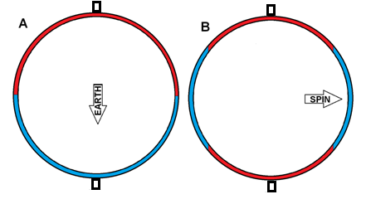
As a thought experiment, consider two concentric spheres of 8,000 inches and 8,120 inches diameter spinning on an axis. We shall suspend the smaller sphere inside the larger sphere. The smaller and larger spheres are equidistance to each other at all points. The spheres rotate on a common axis, which we shall call the poles.
Figure 2
`As a simplification, we shall fill the space between the spheres with two liquids. The red fluid is less dense than the blue fluid. The fluids will not mix. The fluids are of equal volume. The total volume of the liquids will completely fill the space between the spheres.
In order to rotate the spheres we will mount them on an axis penetrating the sphere through it center and extending out past the outer sphere. We shall arbitrarily designate one end of the axis as the North Pole.

In earth's gravitational field
In panel A of Figure 2 depicts the results if we place the concentric spheres at any place on earth's surface with the sphere's North Pole pointing toward space and South Pole pointing toward the earth's center. The force of gravity (increasing with motion toward the earth's geographic center) causes the liquids to settle. We can expect the heavier (blue) fluid to migrate to the South Pole and the lighter fluid (red) to migrate to the North Pole. After an appropriate settling time the liquid in the volume between the spheres will settle with the red (lighter) liquid in the North half and the blue (heavier) liquid in the South half. This is because the force field we call earth's gravity causes the heavier (blue) fluid to displace the (red) lighter fluid.

In space (B)
Let's change the conditions somewhat by removing the external gravitational field, say by asking Mr. Musk to take the concentric spheres into orbit where Earth's gravity offsets centrifugal force created by circular movement around the earth.
We can then spin the spheres on their common axis. The lighter (red) fluid will move toward the sphere's poles and the heavier (blue) fluid will move toward the sphere's equator. Centrifugal force caused the heavier (blue) fluid to displace the lighter (red) fluid at the sphere's equator. The force (pointing around) causing the liquids to settle at the edges is Earth's centrifugal force.

Evaluation
Liquid movement in the spheres spinning outside the influence of an external gravitational field illustrates the basic concept of horizontal (or tangential) weather. In earth's atmosphere, the lighter (more buoyant) fluids will centrifitate (as opposed to gravitate) toward the poles, and heavier (less buoyant) fluids will move toward the equator.

Sphere equivalence
The space between the spheres represents earth's atmosphere. In our thought experiment, the liquids don't fly out into space because of the outer sphere. Earth's atmosphere doesn't fly into space because earth's gravitational force retains it. I can therefore say that earth's surface and gravity contain its atmosphere just as effectively as the two concentric spheres contain their red and blue liquid. This is a reasonable analogue to Tangential Force on earth's atmosphere.

The space between the spheres, and the atmosphere’s volume — determined by land on the bottom and gravity limiting vertical movement above — both define atmospheric corridors that limit the movement of colored liquid in the first case, and air in the second.

Ramp equivalence
Placing an object in a gravitational field on a frictionless ramp, the force is reduced by the sine of the ramp's angle to the gravitational field. Centrifugal force is also a field. The atmospheric corridor is the equivalent to a ramp and the centrifugal is perpendicular to the earth's axis of rotation, therefore the effective force on the atmosphere is cos(lat) to establish the centrifugal force at that latitude multiplied by sin(lat) to establish the fraction of the force after modification of the travel vector inside the atmospheric corridor. This quantifies horizontal motive force (HMF) on the atmosphere within the atmospheric corridor.

Tangential Weather Force
Because we are actually interested in the force generated to accelerate air we must multiply the horizontal motive force by differential density of the atmosphere giving us the Tangential Weather Force which drives atmospheric motion.
$$TWF=\frac{{\left(\frac{4.0075X{10}^{7}m}{86,164s}\right)}^{2}}{{6.378 X 10}^{6}m}*\cos\left(lat\right)*\sin\left(lat\right)*ρ_{diff}$$
the mv²/r term is a constant so on earth
$$TWF=0.033916*\cos\left(lat\right)*\sin\left(lat\right)*ρ_{diff}$$
For the purpose of this paper, I’m assigning λ the value 0.033916, representing the magnitude of centrifugal acceleration at Earth’s equator — but only when λ is used in the context of weather science.
Because of the temperature and humidity differential between arctic and tropical atmospheres a moderate value of $ρ_{diff}$(0.08) is used for modeling and graphing purposes.
You may find the next section redundant. This section explains TWF's derivation and calculation technically with fewer conceptual leaps. The author often uses the terms tangential and horizontal interchangeably. This is by design. To an observer on the ground gravity is up at all points on the globe. Horizontal Force is horizontal (parallel to the ground) at all points although the value is zero at the horizon and the poles.
A horizontal force is what an observer perceives and tangential is the mathematic treatment of the force's result. Horizontal force is across the ground toward the horizon while tangential force is parallel to the ground and perpendicular to gravity's force.
Tangential force is just as real as gravity and just as effective even though it is of a different magnitude and its field strength profile (discussed below) is unique.
The author has decided to designate Horizontal Force as the gross force created on all suspended objects in the atmosphere due to centrifugal force as modified by the atmospheric corridor. TWF (Tangential Weather Force) is the force created exclusively on atmospheric packets due to differences in their buoyancy.

Deriving TWF
The mathematics of tangential weather force is not difficult especially compared to calculations of differential humidity.

Centrifugal force
The first step is to determine the centrifugal force created by the earth's rotation at the equator. The velocity formula is$v=\frac{d}{t }$.
$$\frac{4.0075 X {10}^{7}m}{86,164 \frac{s}{d}}=463.82 \frac{m}{s}$$

The centrifugal force formula is $F= \frac{{mv}^{2}}{r}.$ At the equator the centrifugal force is
$$\frac{1kg·{\left(463.82 \frac{m}{s}\right)}^{2}}{6.378 X {10}^{6}m}=0.033916N$$
This is not a new discovery. Ferrell did the same calculation in his book and got very nearly the same number.
Notice that the atmosphere serves as the ramp in dynamics. The force is multiplied by the cosine of the angle of effective force angle. At 45° the effective force angle is 45° because the angle of the atmospheric channel is 45° to the earth's axis of rotation. At 30° latitude, the angle of the atmospheric rotation is 30° to the earth's axis of rotation, and so forth.
Centrifugal Force is the blue dot dot dash line in Figure 3. Tangential Force is the red dashed line in Figure 3.
At 45° latitude centrifugal force is
$$\frac{\left(463.82 \frac{m}{s}*\cos\left(45°\right)\right)}{86,400s}=0.016865N$$
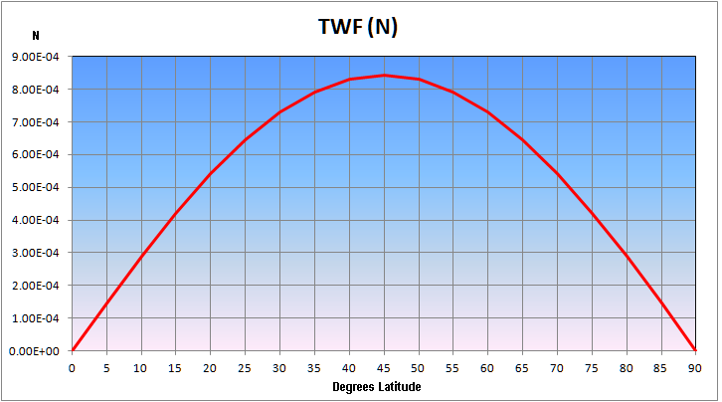
The centripetal force at 45° latitude is $0.016865N$. That is true of north latitude or south latitude. Centrifugal force on the earth's surface is small compared to gravitational force.
Figure 1
The dash dot curve in the accompanying figure is Centrifugal force plotted against latitude.
Notice that centrifugal force is zero at poles and maximum at the equator, while tangential force is zero at the poles and equator and maximum at 45° latitude. This limitation of centrifugal force to tangential values is due to the effect of the atmospheric channel. Said another way, horizontal (tangential) force is the result of centrifugal force acting on the fluid (atmosphere) within the atmospheric channel.

Tangential Force
Centrifugal force interaction with the atmosphere is complicated. In our thought experiment, we have a channel between two spheres. The ground assumes the function of the inner concentric sphere's outer surface and gravity assumes the function of the outer concentric sphere's inner surface. Centrifugal force is limited to the atmospheric channel because the air's movement is limited to the space between the surface of the earth and the gravity imposed upper limits of the atmosphere.
The atmospheric channel vertically confines centrifugal force to its confines between the earth's surface and the edge of space limiting its magnitude. However, and I cannot accentuate this enough, it is the combination of centrifugal force and the atmospheric channel the source of the horizontal component of both the gross horizontal force and resulting Tangential Weather Force caused by differential buoyancy. The definition of tangential on a sphere is horizontal to a single point on the sphere's surface, which an observer interprets as toward the horizon.
Mathematically tangential (horizontal) force is the vector result of both centrifugal force and the atmospheric channel. Centrifugal force is perpendicular to the earth's axis of rotation. Airflow is restricted to the atmospheric channel resulting in a final horizontal force that is minimal at the poles and the equator and maximal at 45° latitude. The limiting mathematic function of the atmospheric channel function is the sin of latitude.

$$F_{tan}=\sin\left(lat\right)*Fc\left(lat\right)$$
Where
$$F_{tan}$$ | is Tangential force
$$Fc\left(lat\right)$$ | is centrifugal force
$$\sin\left(lat\right)$$ | is the sin of the latitude

The accompanying chart illustrates centrifugal force and tangential force at latitudes. The chart is applicable for both north and south hemispheres.

TWF
Tangential force is the maximum available centrifugal force within the atmospheric corridor. Tangential Weather Force (TWF) is the force available due to atmospheric differential density. There would be no movement of the atmosphere if all of it were the same mass per unit volume or density. However, if one air mass is denser, it will displace an air mass of less density in the direction of the force applied. Horizontal force is greatest at the equator and least at the poles, therefore heavier air will displace lighter air at the equator.
In the case of Tangential Weather Force, the force is tangential to the earth's surface. TWF differs from tangential force because it proportional to the tangential force multiplied by differential atmospheric density or the difference in density between warm humid light air and cold dry heavy air.
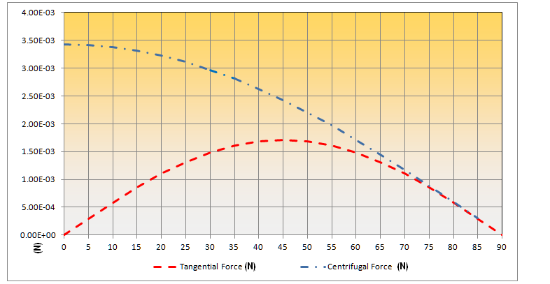
The mathematic relationship between horizontal and TWF forces is
Figure 2
$$F_{TWF}= F_{hor}* \left(ρ_{1}-ρ_{1}\right)$$
Where
$F_{TWF}$ Is Tangential Weather Force
$F_{hor}$ Is Horizontal Weather Force
$ρ_{1}$ Is density of air mass #1
$ρ_{2}$ Is density of air mass #2

Combined vertical and horizontal weather forces
Centrifugal force modified by the shape of the atmospheric corridor creates horizontal (tangential) forces, which transport heated air to the poles and cooled air to the tropics. Nature masks the horizontal (tangential) weather effect effectively because the buoyancy differential of polar air and equatorial air is about 8%.
Gravity is responsible for vertical weather effects. The atmosphere accelerates very quickly because of the magnitude of gravity's force, which is $9.81\frac{m}{s^{2}}$. Vertical weather effects on individual air molecules are on the order of minutes.
Centrifugal force is at most 0.34% of gravity or about one part in 300. Tangential force is 0.172% of gravity or about one part in 600. TWF is only as effective as the density difference of the air parcels it affects. Assuming 8% differential density the force peaks at .0137% of gravity or about one part in 730 when compared to gravity.
You can see how a modeler might easily overlook the effect.
However, that small force may affect a molecule in the atmosphere for hours or days. You will be astonished the speeds and distances that $\frac{1}{720}$ of the force of gravity will accumulate over time.
Earth's weather is a combination of vertical gravity force and horizontal weather force.
Horizontal or tangential weather is the primary force creating large global weather especially weather fronts, trade winds, jet streams, tornados and hurricanes. Horizontal weather fully explains water dependent features such as tropical rain forests, fruitful plains and deserts.
Vertical weather is due to gravity creating vertical weather effects such as clouds, rain, thunderstorms, isolated tornados and other local weather effects. Gravity is a much stronger and more energetic field. Weather effects created by gravity tend to be more intense but of a shorter duration.
Cyclones are cyclones. The hurricane is an example of combined vertical and horizontal weather effects. The central core of a hurricane is simply a ring of thunderstorms. The hurricane is the cyclonic conduit of tropical buoyant air from ocean level to the troposphere (and higher). The volume of air and an unmentioned reverse Coriolis effect is responsible for the thunderstorms. The thunderstorms are a result of vertical weather, but horizontal weather is responsible for collecting those thunderstorms in a circle and moving them halfway across the globe.
Vertical weather and horizontal weather both affect weather because of atmospheric buoyancy differences acted on by gravity and tangential weather forces respectively.

TWF effectiveness
It is time for just a bit of refresher. The atmosphere's density is a function of solar radiant energy captured in the form of heat. Heat exchanged with the atmosphere over land is much greater than over water. The result is that when there is no sunlight, the atmosphere's temperatures over land are cooler than over water. When there is sunlight, the atmosphere's temperatures over land are greater than over water.
It is important to note that during summer the humidity over arid land is higher than over water.
Simulation note: Ice and snow are more similar to land than water with respect to thermal capacity and transfer.
Simulation note: Ice and snow must go through the liquid phase before they can contribute humidity to the air.
As a result, denser (less buoyant) polar air displaces lighter, more buoyant equatorial air in the equatorial areas moving them toward the poles and away from the equator.
This energy source moves weather fronts from the poles to the equator and back again. Without this movement and heat transfer the equator would be too hot and the poles too cold for human habitation.
Someone might ignore TWF because of its magnitude (value). The greatest horizontal weather force is at 45° latitude. Centrifugal force at 45° latitude is .00243N. Horizontal force at 45° latitude is 0.00168N. TWF at 45° latitude and 8% differential buoyancy is 0.0001344N.
$$displacement=initial velocity+\frac{acceleration*{time}^{2} }{2}$$

$$3,135,000m=0+\frac{0.0001344N ∙216,000s}{2}$$
An atmospheric parcel accelerate by 0.0001344N for 5 days will travel about 3,135 km without any losses such as resistance, turbulence or surface drag. This is an extreme oversimplification because TWF varies greatly with latitude and no resistance of any kind is considered, but it shows that TWF is a force to be reckoned with.

Water in the atmospheric volume
The thought experiment presented in this paper's abstract illustrates the base concept of TWF acting on atmospheric density to create horizontal weather. We've only discussed density effects due to temperature changes.

Water changes everything.
The earth's solid surface corresponds to the inner sphere of the thought experiment while the outer sphere corresponds to the top of the gravity-limited atmosphere. Weather-generation is usually limited to the lowest 10,000 feet (1/3rd) of altitude. Water is rare above 10,000 feet and generally in solid form (ice). Above 10,000 feet, water is rare and usually exists in solid form (ice). When it does appear, it's often due to intense events like thunderstorms, tornados or hurricanes.
Weather is mainly concerned with water vapor and liquid. Ice appears in several forms, each behaving differently in the atmosphere. Very small ice particles with high surface area-to-mass ratios drift passively like dust motes. Mid-sized, structured forms such as snowflakes move slowly with the air and contribute little to vertical transport. Large hailstones, by contrast, fall rapidly like rocks, punching through the atmosphere with high momentum but minimal interaction with surrounding air.
Simulation note: Frozen precipitation is a much less effective air pump than raindrops. Snow's surface area to mass is atypical for ice because of its geometry causing it to 'float'. Frozen ice crystal's surface to mass ratio low but its total mass is small resulting in dust-mote type float. Hail is the opposite end of the spectrum; its surface area to mass ratio results in high terminal velocities and maximal damage to people and things. Danger Will Robinson - all hail is breaking lose.
Simulation note: There is an inverse relationship between atmospheric pumping volume and hail diameter.
Simulation note: There is also a significant (minutes) time delay between ice (hail) arrival to ground level and resulting atmospheric cooling.
Earth's atmosphere consists of gaseous fluids with varying amounts of water in gas, liquid and solid phases. Sunlight powers changes between water's phases. Liquid water adsorbs heat converting it to a gas referred to as humidity.
Simulation note: Water requires input energy to evaporate, removing that energy from ambient air.
Simulation note: Water condensation outputs energy to evaporate, adding that energy to ambient air.
Simulation note: Water transfers heat energy to the atmosphere when it condenses.
The primary motivation for earth's weather is temperature. Dry air density changes by about 4.7% over the range of 32° F (0° C) to 100° F (37.7° C). Polar air can more than double that amount under extreme conditions. The formula for air density is
$$ρ_{air}= \frac{P}{{T*R}_{air}}$$
Where
$ρ_{air }$ is density of air $\frac{kg}{m^{3}}$
$P$ Is air pressure in Pascals
$T$ Is Air temperature in °K
$R_{air }$ is $\frac{287.05 J}{kg K}$
The purpose of showing you the formula is to demonstrate that the density of dry air between 0°C (32° F) and 37.7° C (100° F) is relatively linear.
When humidity is involved, the formula becomes
$$ρ_{air}= \frac{P_{d}}{{T*R}_{d}}+ \frac{P_{v}}{{T*R}_{v}}$$
$ρ_{air }$ Is density of air in units of $\frac{kg}{m^{3}}$
$P_{d}$ is Partial pressure of dry air in Pascals
$P_{v}$ is Partial pressure of water vapor pressure Pascals
$T$ is Air temperature in °K
$R_{d }$ is the specific gas constant of dry air $\frac{287.05 J}{kg K}$
$R_{v }$ is the specific gas constant of dry air $\frac{461.495 J}{kg K}$
This is decidedly non-linear because of water's phase change at 0° C.
The important take away here is that at near 0°C density change for relative humidity change is small and much more significant near 37°C. In other words, density changes for changes in humidity AND temperature are non-linear.
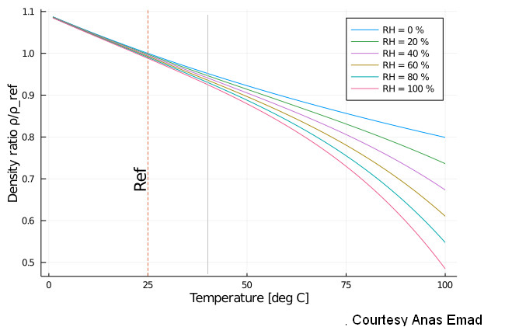
Figure 3
Simulation note: It is probably best to calculate air density by means of a fixed table lookup. A significant advantage to table lookup is that it provides a certain amount of smoothing results in large arrays if applied in three dimensions.
Simulation note: This text speaks in broad terms. In reality, the atmosphere is a constantly moving three-dimensional matrix. Practical changes in air density will change small amounts from one calculation volume to the adjacent calculation volumes. Depending on calculation volume size significant density changes might be on the order of one part in 10,000 and 'smoothed' (integrated) over numerous calculation volumes.
Simulation note: A very significant point to consider is that ground foliage can easily exceed 50°C and 99% humidity providing very high values of near-ground differential density values.
Simulation note: The author is actively studying stagnation layers during the writing of this text. The core of stagnation theory lies in the interaction of temperature and humidity just above ground level and below cloud level. Stagnant air inhibits vertical movement, preventing the initial vertical air exchange—or corridor formation—that would otherwise be expected. This allows the unstable condition of buoyant air trapped beneath denser air to persist. With luck, a working model will be completed by publication time.

Variations in atmospheric buoyancy due to cooling at polar latitudes creates higher density (heavier) air, which displaces lower density air at the solar equator, just like the concentric sphere thought puzzle above.
Liquid water in the form of oceans, gulfs, lakes and ponds tend to heat and cool slower than land, especially deserts. As a result, air over land heats from solar irradiation and cools by radiation of heat to space quicker and to greater extremes than air over water.
In the continental United States, colder (heavier) air fronts move southward over the continent displacing warmer (lighter) tropical air eastward and northward.
Topological features of Continental North America, specifically the Rocky Mountains and Appalachian Mountains combine to assist cold air's movement to the Gulf of Mexico and Caribbean displacing warm-humid (lighter) tropical air to the northeast warming western Europe and the Baltic area.

Atmospheric TWF effects

TWF is a remarkable tool. Once the basic concept and mathematics were established, it immediately explained phenomena the author had not previously understood. The TWF concept suggested solutions to problems not yet considered, such as the static zones at the equator (the Intertropical Convergence Zone, or ITCZ) and the poles.
TWF reaches its maximum values in the middle latitudes of both hemispheres, driving the majority of Earth’s large-scale, persistent weather. In contrast, the tropics and poles experience very little horizontal motion due to TWF. The most consistent, reliable winds, including the jet streams and trade winds, form where TWF-accelerated air flows through the middle latitudes.
Equatorial and polar air masses are largely unaffected by TWF. The densest air remains near the poles because TWF is so low. The most buoyant air remains at the tropics because the force of TWF is also low there. If another force such as such as convection (vertical air movement created by gravity's force acting on differential air density) responsible for large-scale meridional air movement, it would dominate at the solar equator, but it does not. Wind as the ultimate expression of weather, is strongest at the mid-latitudes, between the tropics and Polar Regions, where TWF is the greatest.
While the tropics receive enormous amounts of solar energy and span both sides of the equator, they are relatively calm. Classic weather theory would predict violent conflict between hemispheres, but instead, thundershowers, humidity and widespread calm characterize the tropics. Historically, sailors called the tropics the doldrums. TWF explains this paradox: because horizontal force approaches zero at the equator, there is simply no horizontal engine to drive equatorial turbulence.
In contemporary literature, the boundary between the middle-latitude weather zone and the tropics is the Intertropical Convergence Zone (ITCZ). It is easily recognized in satellite photos as a band of thunderclouds. If solar energy drove earth's atmospheric circulation, the ITCZ would track the sun's greatest energy. During solstice, the solar equator shifts approximately 23.4° north or south due to Earth’s axial tilt. However, the ITCZ moves only slightly, much less than this full angle, because of the stabilizing influence of TWF.
If the ITCZ were driven solely by solar intensity, it would swing dramatically with the seasons. But it doesn’t. Its relative stability is further evidence that TWF, not solar heating alone, anchors its location.
This prediction is confirmed by the presence of a near-permanent band of clouds near the equator, where cooler, denser air from the mid-latitudes (now warmed and humidified, but still heavier than tropical air) flows toward the solar equator.
Arriving Atlantic Circulatory Air slides beneath the lighter, moisture-laden equatorial air. The adiabatic cooling of rising equatorial air produces clouds and rain. This boundary-induced vertical motion is real, but it is often misinterpreted. It does not form cells. Rather, it is a consequence of TWF displacing air masses into one another, causing vertical reactions at the collision boundary. This vertical convective air motion, noted by Halley and claimed as the source of weather by Hadley and others, is a local effect. This visible vertical motion, which originally inspired Hadley, Ferrel and polar cell theories is a limited area vertical convective phenomenon.
TWF also accounts for the characteristic "flower pattern" of Arctic stagnant air. As buoyant TWF-driven air flows northward, it encounters near-static polar air. The northward travelling air cools and diverts to the south and east. The northward inertia of the atmospheric Gulf Stream exerts pressure on the stagnant polar air pushing it toward the pole, creating the observed petal-like distribution.
That same motion creates the jet stream. The jet stream is a classic example of a fluid jump where a low-level impediment to motion causes the inertia of following air to divert leading air upwards and over the barrier. As northbound air moves from the tropics, it is moving from a wide area at the lower latitudes to a narrow corridor at the upper latitudes. When any liquid transitions to a smaller available flow area its velocity increases.

Mimics
Horizontal weather sometimes mimics vertical motion. One example is the jet stream above where the collision of northbound tropical air encounters polar air and some of it diverts into the upper troposphere. When fast horizontal airflows encounter mountains or opposing currents, they are deflected upward resulting in vertical travel but caused by horizontal air movement.
Conversely, vertical weather mimics horizontal motion every day in Florida where westward-traveling diurnal storm fronts resemble cold fronts. The parallel line of westbound weather is the result of daily heating differences over land and water along a north south oriented oceanfront.

